Assignment3 Report

Shenyu Gu, 301385392. This project use (1 out of 5) late submission days, excusing for part 3 model adjustment to get better performance.

# Part1

1. List of the configs and modifications that you used.
   1. **Configs:**Model: COCO-Detection/faster_rcnn_X_101_32x8d_FPN_3x.yaml  
      Batch of data: 3  
      Basic learning rate: 0.0002  
      Iteration: 2500  
      Batch size per image: 128
   2. **Modification with improves:**
      1. Crop the original data set to get the relatively smaller picture and a relatively large plane as follows:  
         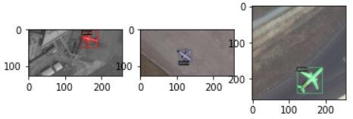
      2. Randomly rotated the cropped picture as well as their mark json to increase the variety of the training set.
      3. When identifying high-resolution pictures, separate them into multiple 512*512 pictures, with 256 px stride. Then merge the identified result and run the NMS algorithm to remove the overlapped bounding boxes.
   3. **Final plot for total training loss and accuracy**  
      Loss of box Identification:

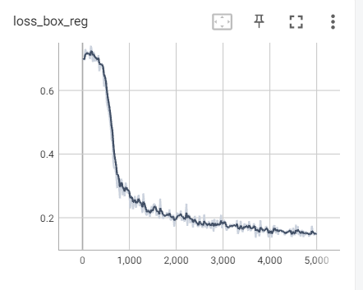

Training Accuracy, the val set is a random cropped RGB picture from the training set:

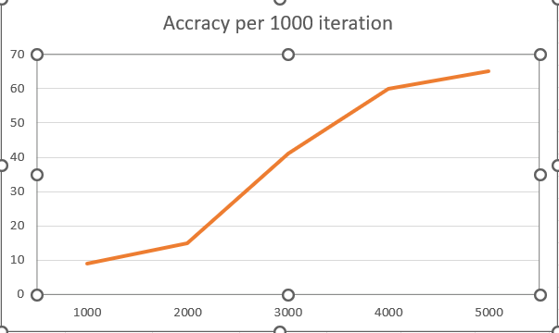

By learning about accuracy and loss, the training of over 3000 have the probability to overfit the set

* 1. **The visualization of 3 samples from the test set and the predicted results:**

As some images in test set is too large, I just crop some pieces of the images, seems overfitting happened, but the in my best submission, the overfitting has been optimized.

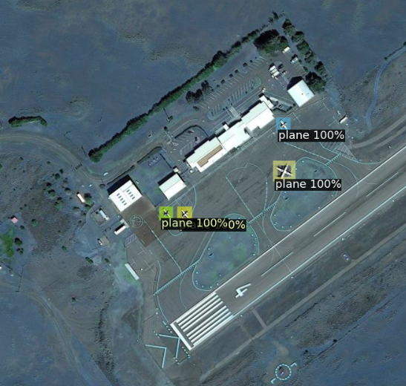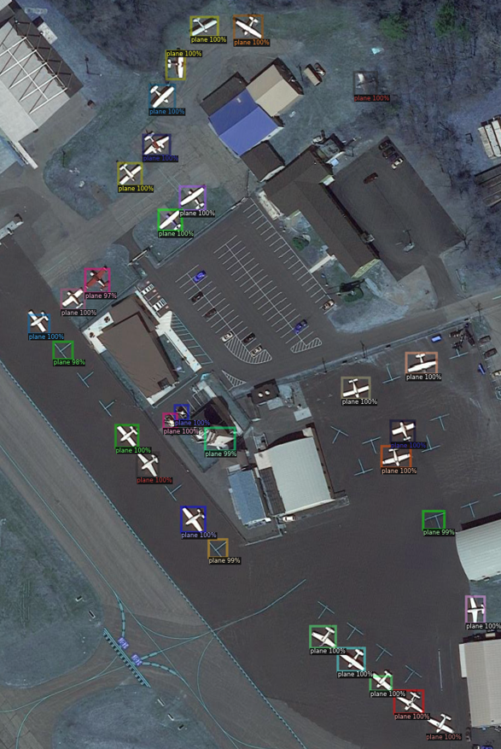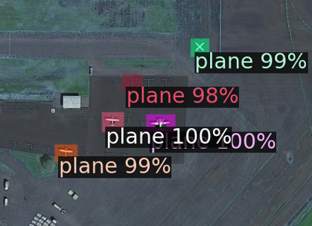

* 1. **Ablation study to validate the choice:**Topic: to check out if the divide and concur the test set works on raising the accuracy of image identification:  
     Result as follows: the value of the table is the predicted mark over Kaggle:

|  |  |  |  |  |  |
| --- | --- | --- | --- | --- | --- |
|  | Iter = 1000 | Iter = 1500 | Iter = 2000 | Iter = 2500 | Iter = 3000 |
| No Crop data set | 0.33226 | 0.33724 | 0.36213 | 0.33743 | 0.37244 |
| Crop the data set | 0.45731 | 0.45582 | 0.45141 | 0.46735 | 0.36993 |

This shows that the crop and concrete identifying result can significantly improve the accuracy. And 2500 seems the best-identified result.

# Part2

1. **Hyperparameters I used:**

num_epochs = 10

batch_size = 10

learning_rate = 0.0001

weight_decay = 1e-5  
Optimizer = Adam(betas=(0.9, 0.999), eps=1e-08)

Loss = BCEWithLogitsLoss

1. **Structure of the network:**  
   The work as a Residual U-Net, the Form of network is as follows:

* arrow shows the data flow towards.

|  |  |  |
| --- | --- | --- |
| Layer | Encoder | Decoder |
| 1 | Input_conv(3,64) ↓  Residual_block(64,64) ↓ Down(64,128) ↓ | Output_conv(64,1)  Residual_block(64,64) ↑  Conv(128, 64) ↑  Concate(Encode_1, Decoder_1) ↑  Up(128,64) ↑ |
| 2 | Residual_block(128,128) ↓ Down(128,256) ↓ | Residual_block(128,128) ↑  Conv(256, 128) ↑  Concate(Encode_2, Decoder_2) ↑  Up(256,128) ↑ |
| 3 | Residual_block(256,256) ↓ Down(256,512) ↓ | Residual_block(256,256) ↑  Conv(512, 256) ↑  Concate(Encode_3, Decoder_3) ↑  Up(512,256) ↑ |
| 4 | Residual_block(512,512) ↓ Down(512,1024) ↓  Residual_block(1024,1024) → | Residual_block(512,512) ↑  Conv(1024,512) ↑  Concate(Encode_4, Decoder_4) ↑  Up(1024,512) ↑ |

Conv -> {conv(in_ch, out_ch, kernel = 3, stride = 1), BatchNorm2d(out_ch), ReLu()}

Up -> {Upsamle(scale_factor = 2), Conv(in_ch, out_ch) }

Down -> (Conv(in_ch, out_ch), Maxpool(2))

Residual_block -> {Conv(in_ch, out_ch), Conv(in_ch, out_ch), output = conved tensor + input tensor},

Residual block requires in_ch = out_ch

The reason for applying U-Net: U-Net has practically proved good performance in semantic segmentations.

The reason for applying Residual Block as backbone: To avoid overfitting during training.

1. Visualize 3 examples from testing set:  
   P2239.png

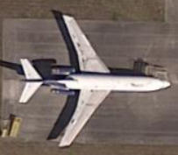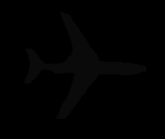

P1376.png

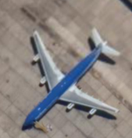

P1742.png

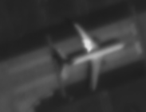

1. Training loss and IoU:  
   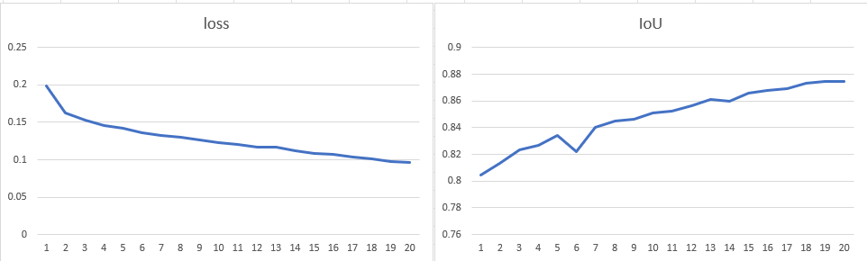
2. Final Mean IoU:  
   images: 1430, Mean IoU: 0.8740517059633856

# Part3

1. Name on Kaggle: Shenyu Gu. Member in the group: Shenyu
2. Best score: 0.46735
3. Random visualization:

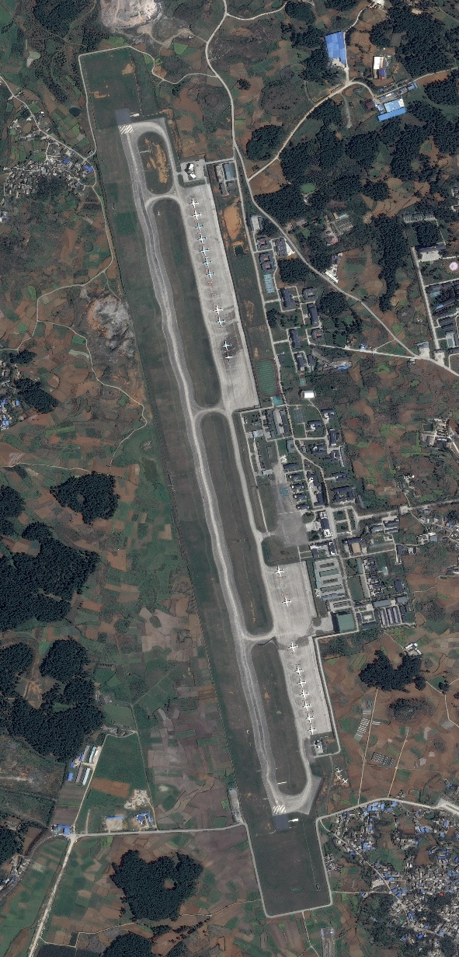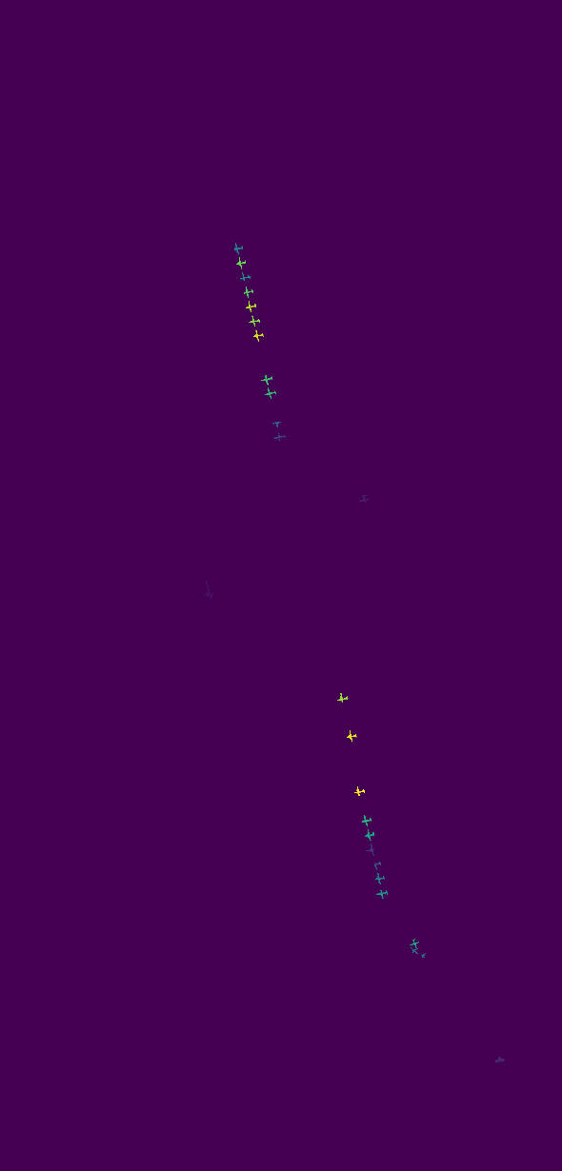

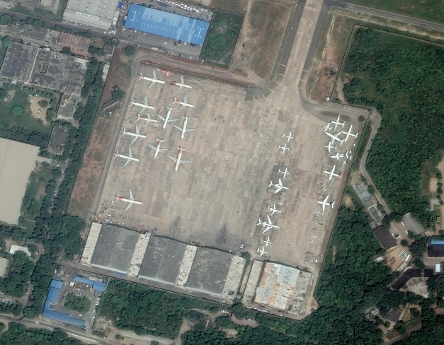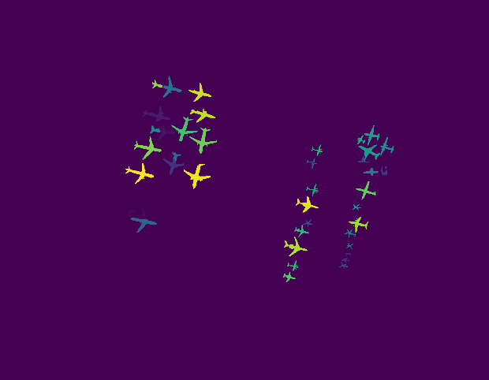

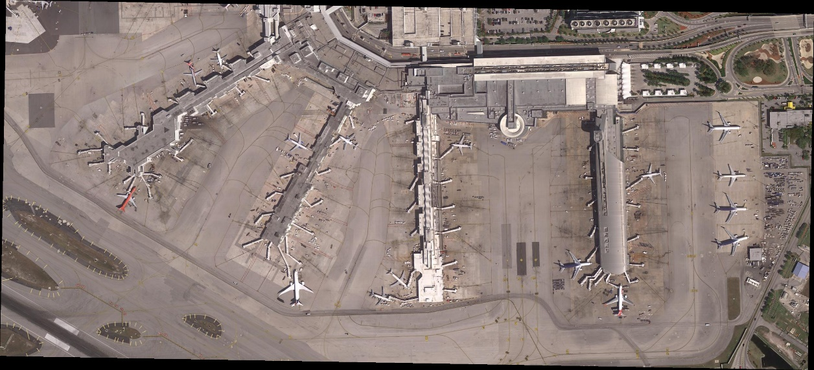

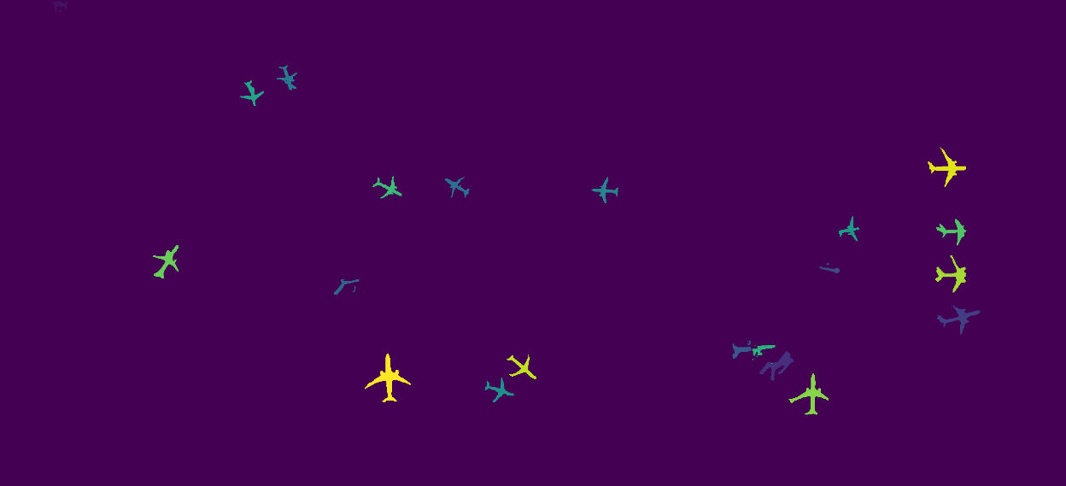

1. Pred has been uploaded.

# Part4

Use fast mask rcnn for 1000 iterations, learning rate = 0.00025

Visualize the predict map is as follows:

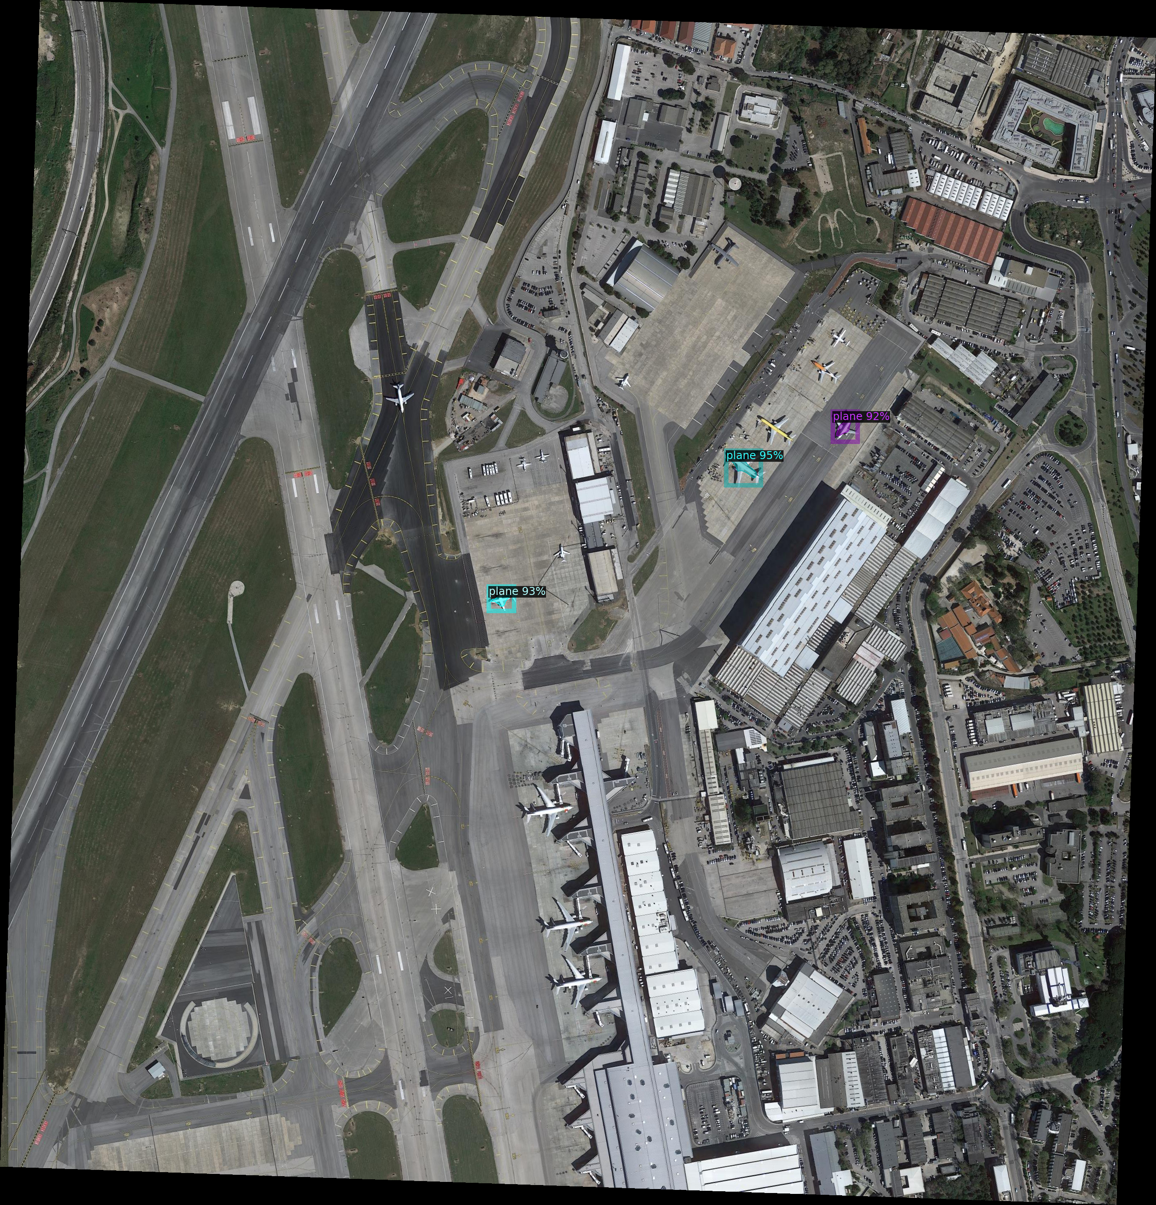

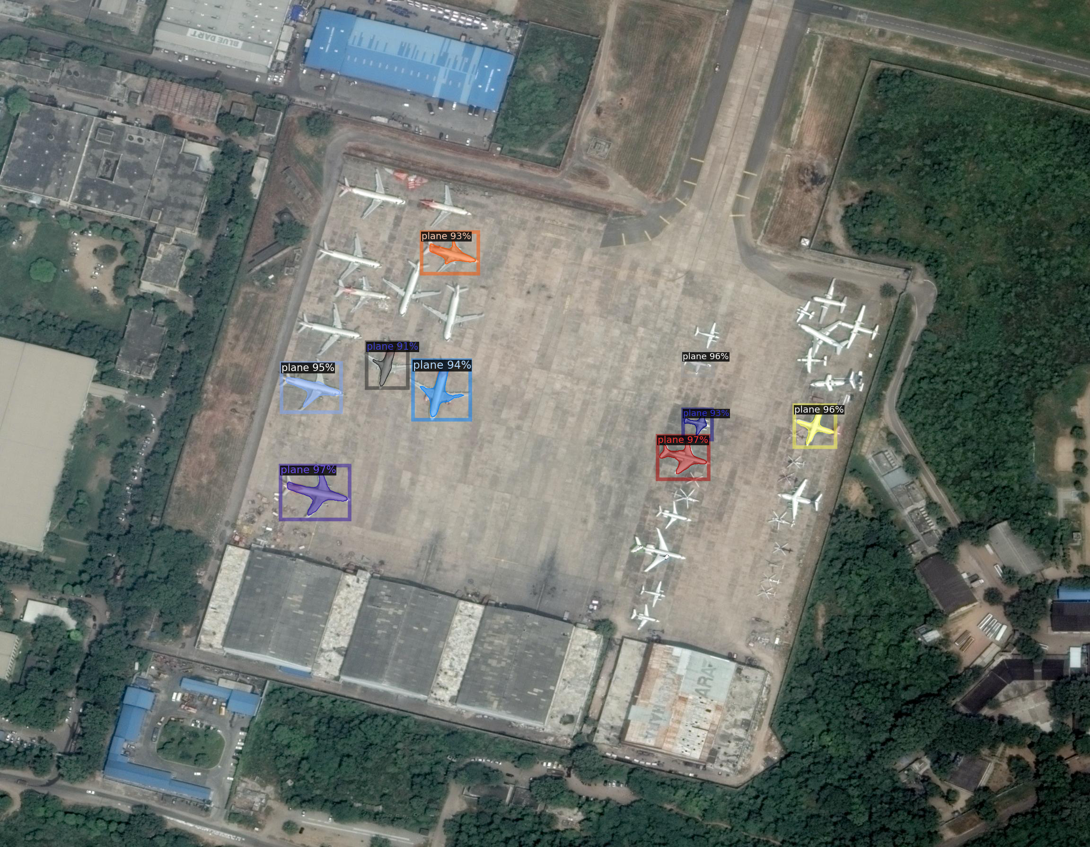

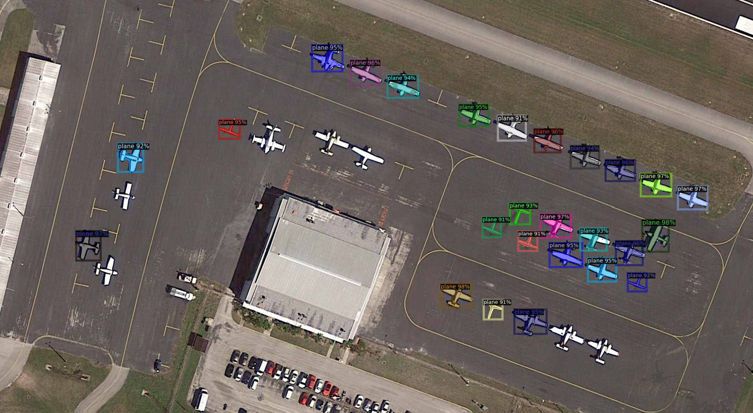

Difference: The fast mask RCNN has higher speed in training and output results. But not perform well in some high-resolution images with small planes. However, what we did in part 3 has higher accuracy, but the speed is slow. Fast mask RCNN is more fit for in-time identification output, but the instance segmentation in Part 3 is more fit for high resolution identification.